MORNING WORSHIP SERVICE
Dec 31, 2017

Opening “The Family of God” 386

Opening Prayer/Announcements

Worship Hymns “Sweet, Sweet Spirit” 243
“Blessed Assurance, Jesus Is Mine” 334
“Because He Lives” 407
“Something Beautiful”
“You Are My Hiding Place”

Offertory
Sr. Women’s Sunday School Class Topics

Jan 7th Achsah – Caleb’s daughter Joshua 15:13-19
Jan 14th Adah & Zillah – Lamech’s two wives Genesis 4:19-24
Jan 21st Ahinoam – The wife of Saul 1 Samuel 14:50
Jan 28th Bilhah & Zilpah – Two slaves Genesis 29-30; 35:22-25

Special Music

A Place for Everyone – See you there at 9:45
Sermon Bro. David Atwood
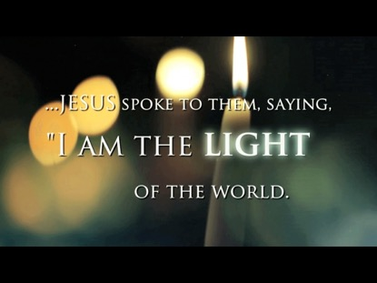
W

Invitation “Just As I Am” 307

Join Our New Year’s Eve Watch Party

NURSERY – available for children age 0 to Kindergarten
Terri Edwards, Patti Radford

Hostesses/Hosts for Dec Ushers for Dec
Nattie Garcia, Bobby & Diann Stutes Jimmy Beauchamp, Rick Tooley
Michael & Peggy Hammonds Mickey Stanford, Sam McManus

Immediate Need Prayer List
Prayer & Request Information

(Please complete name & address information on reverse side)

❑ I would like to speak with the Pastor.

❑ I would like more information on this church.

❑ I have Prayer Requests or Needs

Date:

Permission to Publicize:
Church Bulletin  Yes  No
Email Prayer Chain  Yes  No

Prayer Request:

Prayer For
Name
Address
Phone

Given By
Name
Address
Phone
Please Contact By

❑ Card  Phone  Visit

Comments

Please pray for continued progress for Scott Ruthven
Pray for Jean Griffith as she recovers from respiratory issues
K s b c

Keeping His Word through Sunday School, Bible Study and Church Attendance/Worship

Sunday School Bible Studies for Jan:

Jan 7th Jesus Provides Mark 6:34-44
Jan 14th Jesus Corrects Mark 7:5-15
Jan 21st I Am Wonderfully Made Psalm 139:1-6,13-18
Jan 28th I Am a Child of the King Galatians 4:1-7

